# VELAMMAL ENGINEERING COLLEGE

### (An Autonomous Institution)

**CHENNAI–600066**



Quiz Quest: Battle of Brains

For 1st Year B.E/ B.Tech Students

Organized By

DEPARTMENTOF

## PHYSICS

SUBMITTED TO

ENTREPRENEURSHIP DEVELOPMENT CELLLEMONIVY

### VELAMMAL ENGINEERING COLLEGE

**(An Autonomous Institution)**

# Department of Physics

1. Title of the Event : Quiz Quest: Battle of Brains for 1st Year B.E / B.Tech Students
2. Resource Person :Nil
3. Date :09-12-2024
4. Session Type :Offline
5. Program Type :Quiz
6. Annexure- I :List of Participants
7. Annexure- II :Brochure
8. Annexure-III :Photographs
9. Annexure-IV :Participants Feedback

C:\HV\HV photo,sign,cc\Sign.jpg

|  |  |
| --- | --- |
| **Mrs.G.Hamsavalli**  Assistant Professor EventCoordinator  DepartmentofPhysics | **Dr.S.Shahil Kirupavathy**Professor & HeadConvener  DepartmentofPhysics |
|  |  |

### ANNEXURE-I

**Table1:List of Participants**

|  |  |  |  |
| --- | --- | --- | --- |
| **S.No** | **NameoftheStudent1** | **S.No** | **Nameofthe Student** |
| 1 | Megha Joshy | 18 | Harshini Mohan |
| 2 | Yuvashree | 19 | Jose Misha |
| 3 | Abarna | 20 | Nanda Krishna |
| 4 | Karthikeyan | 21 | Vaishnavi |
| 5 | Leo Calvin | 22 | Sandhiya |
| 6 | Roshini | 23 | Sri Raghav |
| 7 | Pritha | 24 | Pooja |
| 8 | Vasanth | 25 | Dinesh Karthik |
| 9 | Santhosh | 26 | Ruthi Lakshya |
| 10 | Chindu Priya | 27 | Sanjith |
| 11 | Manorajan | 28 | Srinithi |
| 12 | Deepthi | 29 | Lakshmi Narasiman |
| 13 | Bharath | 30 | Subashri |
| 14 | Praveen |  |  |
| 15 | Jaidev |  |  |
| 16 | Mohammed Daniyaal |  |  |
| 17 | Samitha |  |  |

### ANNEXURE –II

### (BROUCHER)

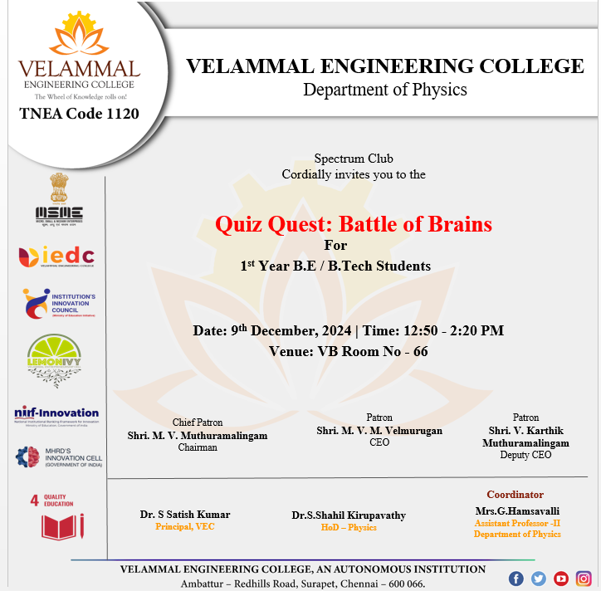

*Figure1: Poster for Quiz Quest: Battle of Brains*

**ANNEXURE–III**

**Photographs**

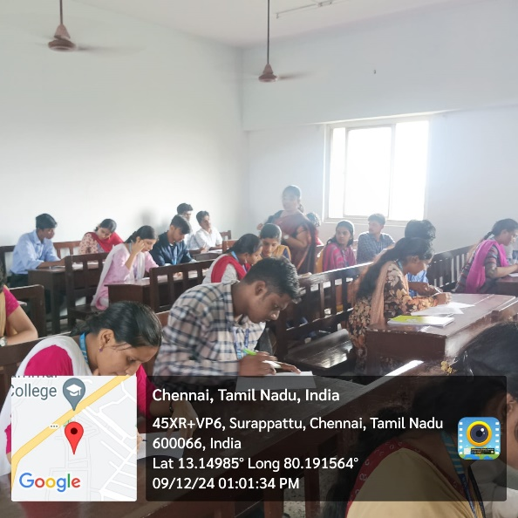

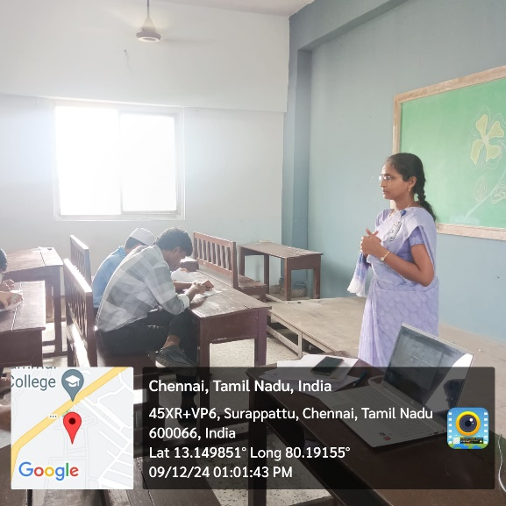

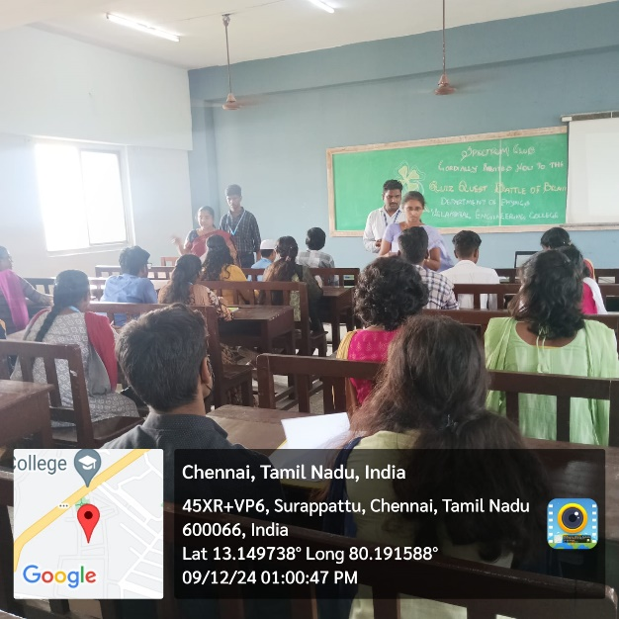

*Figure 2: Students are participating in the event: Quiz Quest: Battle of Brains*

**C:\Users\vec\Desktop\1.tif**

*Figure 3: Certificate of the**event*

**ANNEXURE–IV**

**Table2: Participants Feedback**

|  |  |  |
| --- | --- | --- |
| **Sl.No** | **NAME** | **How was the Quiz Quest: Battle of Brains** |
| 1 | Sri Raghav | Informative |
| 2 | Pooja | Excellent |
| 3 | Megha Joshi | Informative |
| 4 | Yuvashree | Good |
| 5 | Jayadev | Superb |
| 6 | Mohammed Daniyaal | Very Useful |
| 7 | Barath | Good |
| 8 | Praveen | Good |
| 9 | Samitha | Excellent |
| 10 | Harshini Mohan | Very Useful |